WWII Ends in Comeback Fashion

Focus: Invading the Soviet Union turns out to be Hitler’s biggest mistake. Germany suffers major losses. Americans enter the war and open up the western front. This means Hitler must fight a two-front war. After the allies success at D-Day, they launch an attack on Germany from both fronts and win the war.

1. Invading the Soviet Union turns out to be Hitler’s biggest mistake. Germany suffers major losses
- After Autumn 1941the German ¹
- The Russian ² sets in
- Temperatures of 20 below and long supply lines meant that thousands of Hitler’s men ³
- In the first few months of 1942 Hitler decided to move his troops south toward the ⁴ in southeastern Soviet Union
- On the way, Hitler wanted to destroy ⁵. The city Stalin named after himself.
- The Germans and Soviets fought ⁶ over that city.
  - Soldiers would fight for ⁷ to gain control of a single building
- Because the Germans are cut of from supplies and ammunition, they are
⁸ in 1943
  - About ⁹Germans were killed wounded our captured
- Soviets launch a ¹⁰
  - Drove Germany out of the Soviet Union
  - By 1944 Soviet troops were advancing into ¹¹

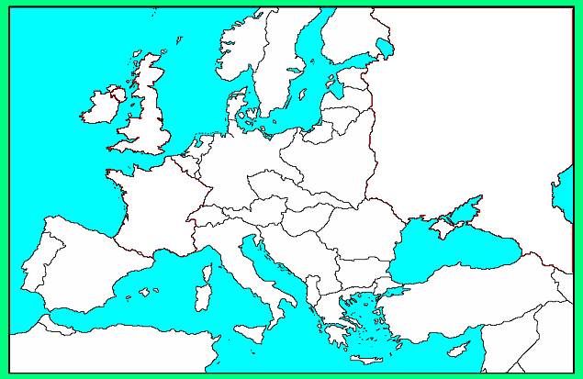
Leningrad
Moscow
1.

2. Americans enter the war and open up the western front. This means Hitler must fight a two-front war.
- U.S. entered the war after the bombing of its naval base called
¹² on December 7, 1941
- By 1944 it was finally ready to help the allies take back western Europe
- On June 6, 1944 the allies landed on Northern France – ¹³
- Germans ¹⁴
- By ¹⁵ the allies took back Paris
- Within a ¹⁶ all of France was free

2.
1.
3.

3. After the allies success at D-Day, they launch an attack on Germany from both fronts and win the war.
- December 1944 Hitler launches a major counterattack that fails at the
¹⁷
- By March 1945 the allies advance into ¹⁸
- Soviets closed in from the ¹⁹
- In Italy, Italians rise up, capture ²⁰ and have him executed
- When Soviets were only 11/2 miles away, Hitler ²¹ in his bunker in Berlin
- On May 7, 1945 ²²
- May 8, 1945 is declared ²³
- World War II didn’t officially end until September 2, 1945 after the U.S. dropped two ²⁴ on Japan to get them to surrender.
- All three ²⁵ powers were destroyed by the ²⁶

