CORRELATION
Correlation is a statistical technique psychologists use to determine the relationship between two variables. If a strong correlation is found, we can use one variable to predict the other.
To calculate a correlation just use Excel to line up your data in two columns like this:
 | A | B
1 | Attendance | GPA | Then just pick another cell and type the formula:  =correl(A1:A8,B1:B8)  The number you get is called a correlation coefficient and is represented by the letter r.
2 | 45 | 4.0
3 | 43 | 3.8
4 | 34 | 3.5
5 | 40 | 3.7
6 | 45 | 3.87
7 | 44 | 3.9
8 | 20 | 1.7
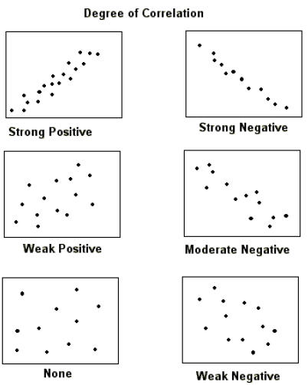
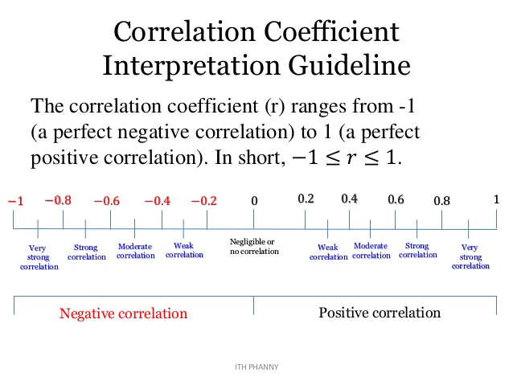
Scatterplots

Helpful Correlations
- SATs and College Graduation Rate
- Self-esteem and depression
- Breast feeding and IQ
- Stress and health

CORRELATION IS NOT CAUSATION!!!!!!!!!!
Just because two variables are related, does not mean one CAUSES the other to change. You may not make any claims about causations because you did not study (or control) other variables. Since the variable(s) you didn’t study may have caused the change, you can’t make any claims about causation.
Examples of correlations that illustrate this:
US spending on science and suicide rates r=.997
Per capita cheese consumption and dying by getting tangled in bed sheets. r=.947
Arcade revenue and computer science doctorates r=.985

