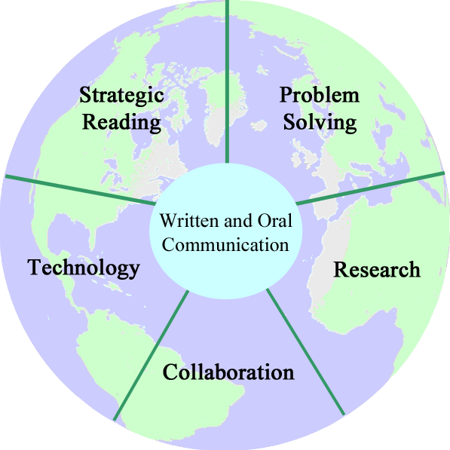Active Citizenship Rubric Committee Draft

Name:
Date:
Skill Score: An active citizen of Weymouth High School . . .
 | Advanced  4 | Proficient  3 | Needs Improvement  2 | Inadequate  1 | Score
Attends school | - No more than 1 unexcused absences for a term.  - No more than 1 unexcused tardy to school per term.  - Receives no discipline referrals for cutting class per term. | -No more than 2 unexcused absences per term.  - No more than 3 unexcused tardies to school per term.  - Receives no discipline referrals for cutting class per term. | -No more than 3-5 unexcused absences per term.  -No more than 4 unexcused tardies to school per term.  - Receives no more than 1 discipline referral for cutting class per term. | -Has 6 or more unexcused absences per term. (Attendance failure)  - 5 or more unexcused tardies to school per term.  - Receives 2 or more discipline referrals for cutting class per term.
Is engaged in the academic experience | - Maintains academic integrity (receives no referrals for plagiarism or cheating.)  - Completes coursework (Receives no “work missing” comment codes on the report card.)  - Adheres to deadlines (receives no “late work” comments codes on the report card.)  - Actively participates in the classroom environment. (receives no “inappropriate classroom engagement” comment codes.) | - Maintains academic integrity (receives no referrals for plagiarism or cheating.)  - Completes coursework (Receives no more than 1 “work missing” comment codes on the report card.)  - Adheres to deadlines (receives no more than 1 “late work” comments codes on the report card.)  - Actively participates in the classroom environment. (receives no more than 1 “inappropriate classroom engagement” comment codes.) | - Maintains academic integrity (receives no referrals for plagiarism or cheating.)  - Completes coursework (Receives no more than 2 “work missing” comment codes on the report card.)  - Adheres to deadlines (receives no more than 2 “late work” comments codes on the report card.)  - Actively participates in the classroom environment. (receives no more than 2 “inappropriate classroom engagement” comment codes.) | - Maintains academic integrity (receives 1 or more referrals for plagiarism or cheating.)  - Completes coursework (Receives 3 or more “work missing” comment codes on the report card.)  - Adheres to deadlines (receives 3 or more “late work” comments codes on the report card.)  - Actively participates in the classroom environment. (receives 3 or more “inappropriate classroom engagement” comment codes.)
Interacts appropriately within the school community | - Receives no discipline referral.  - Receives at least 1 comment code about enhancing the educational environment of the classroom and school” | Receives no discipline referrals for behaviors such as inappropriate behavior or insubordination per term. | Receives no more than 2 discipline referrals for behaviors such as inappropriate behavior or insubordination per term. | Receives 3or more discipline referrals for behaviors such as inappropriate behavior or insubordination per term.
Contributes to the improvement of the communities in which we live by participating in community service | Completes 20 hours or more of community service.* | Completes 10 - 19 hours of community service.* | Completes less than 10 hours of community service.* | Completes less than 5 hours of community service.*
Skill Proficiency Rating | 16-14 | 13-10 | 9-6 | 5-0 | _____Total score
* For terms 1-3 this will be based on last year, for term 4 it will be based on this school year.
This rubric is designed to be run at the end of each term. Students will receive a proficiency level update on each of their term report cards.
A score of proficient or better meets the WHS Active Citizenship learning expectation. 6/17/13 ILT and Aspen Draft

