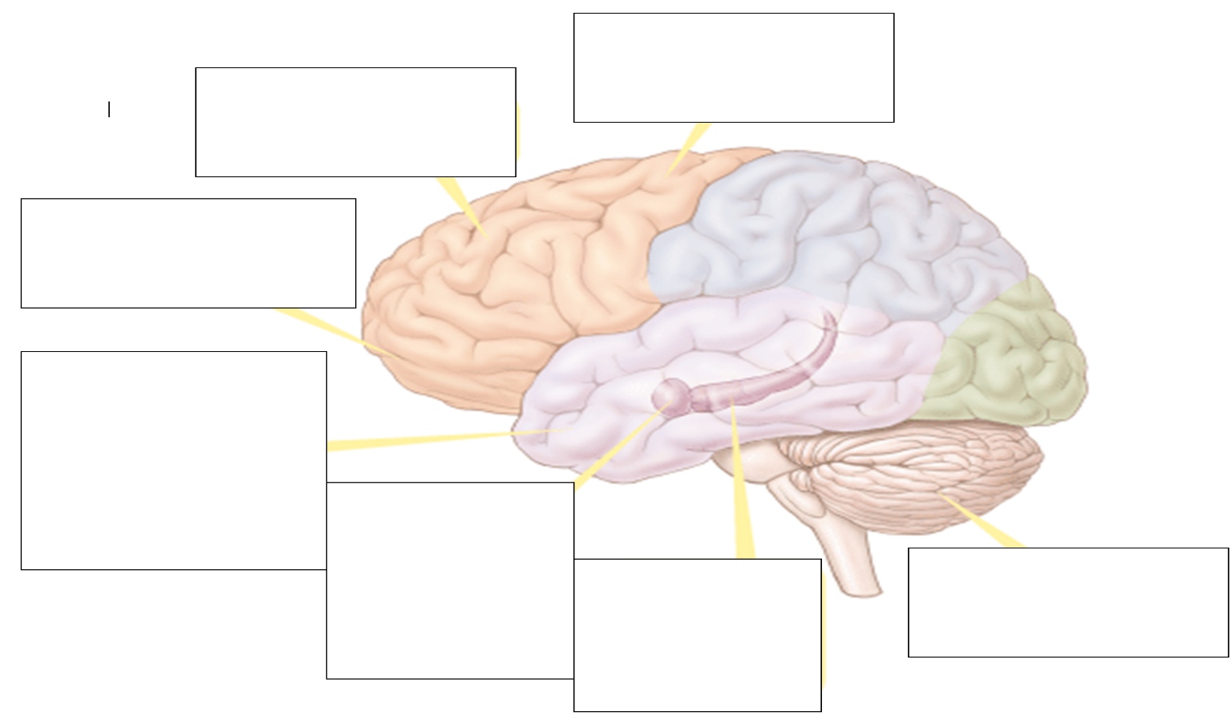
5.6 Biological Bases for Memory - H. Describe and differentiate psychological and physiological systems of short-and long-term memory.
Amnesia
Biology of memory
Process of memory formation
Long Term Potentiation
Where are memories stored?
Explicit Memory System
Implicit Memory System
Stress Hormones
Systems
Forgetting Curve

