

2.2 The Endocrine System  
D. Discuss the effect of the endocrine system on behavior.

Endocrine System

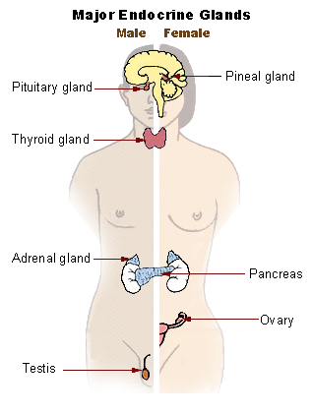

Pituitary Gland

Pineal Gland

Pancreas

Thyroid Gland

Adrenal Gland

Gonads (Testes and Ovaries)