Unit 2 Overview: Imperialism and Africa
(Chapters 3-4, 12-1, 12-2, 15-2, 19-3, 20-2, and 21-2)
Power standards you will develop:
- Imperialism / Colonization  - Impact of War and Conflict | - Attainment of Rights  - Nationalism

Essential questions you will answer:

2-1. What are the motives of Imperialism?
2-1. What are the effects of Imperialism on the continent of Africa?

Building blocks of evidence you will use:
1. Atlantic Slave Trade (3-4)  2. Middle Passage (3-4)  3. Quinine (Galusha)  4. Social Darwinism (12-1)  5. Protectorate (12-1)  6. Sphere of Influence (12-1)  7. Berlin Conference (12-2)  8. Boer War (12-2)  9. Ethiopian King Menelik II (12-2)  10. Apartheid (15-2) | 11. Steve Biko (Galusha)  12. Pan-Africanism (15-2)  13. Coup d'etat (19-3)  14. Nelson Mandela (20-2)  15. Ethnic Genocide (Galusha)  16. Rwanda (Hutus and Tutsis) (20-2)  17. Sudan (Darfur) (20-2)  18. AIDS (21-2)  19. Sustainable development (21-2)

Primary sources you will read and use:

- Rudyard Kipling’s White Man’s Burden
- Berlin Conference Excerpts
- Excerpts of accounts from Rwanda and Darfur

Vocab | Book Definition | Student friendly definition | Context: How is it related to the EQ | Forms of this word you’ll encounter
Imperialism
Colonization
Nationalism
Social Darwinism
Decolonization
Apartheid
Coup d’etat
Ethnic Genocide
East India Company (1600s-1858)

British Raj
1858-1947
1700s

1800s

1900s

2000s

Atlantic Slave Trade
(1400s-1800s)

European Imperialism Timeline Overview

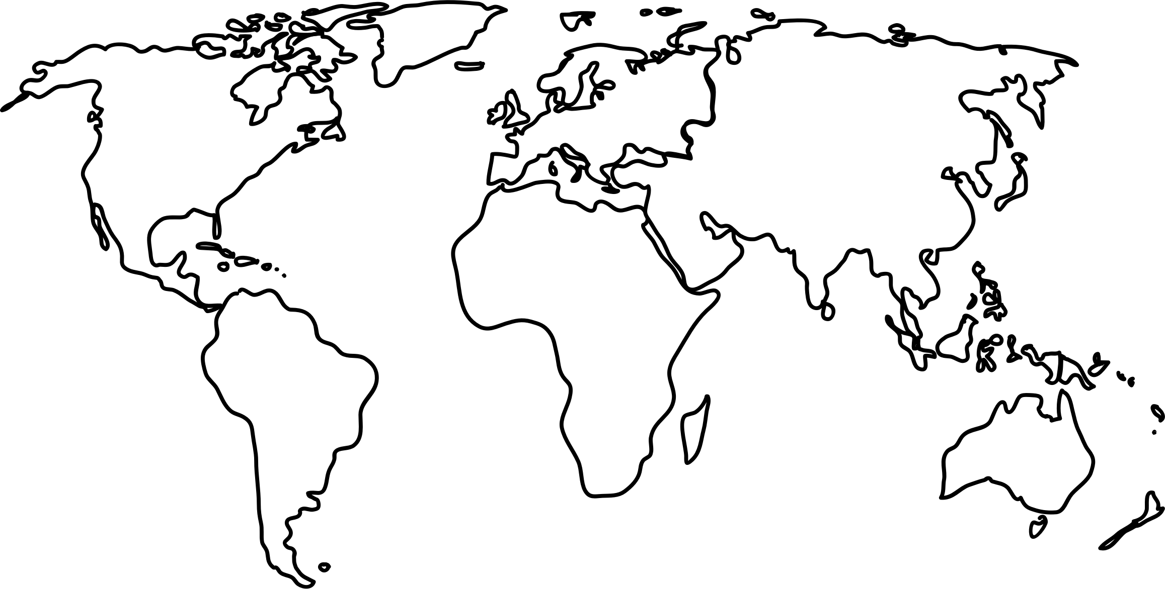

European Industrialization
(1780s-1900s)

European Imperialism of Africa
(1870s-1914)

1948-1994

World Wars
(1914-1945)

Decolonization
1945 to 1990s

1993-1994

2003-2010
2-1. What are the motives of Imperialism?
Guidance: Be careful here. There are real benefits like natural resources, new markets and military bases that drew European nations to imperialize. There are also ways of thinking that allowed Europeans to excuse their actions, like Social Darwinism. On top of this, there are intangible benefits like nationalism. Solid answers will take all of these causal elements into account.

Now give your answer and back it up with evidence from the building blocks:

2-1. What are the effects of Imperialism on the continent of Africa?
Guidance: Solid answers will look at the immediate impact, some of which was good, but will also extend answers to the long term effects and connect it to the problems faced by Africa during genocide and the problems that continue to plague the continent.

Now give your answer and back it up with evidence from the building blocks:

“The White Man’s Burden”: Kipling’s Hymn to U.S. Imperialism
In February 1899, British novelist and poet Rudyard Kipling wrote a poem entitled “The White Man’s Burden: The United States and The Philippine Islands.” In this poem, Kipling urged the U.S. to take up the “burden” of empire, as had Britain and other European nations. Published in the February, 1899 issue of McClure’s Magazine, the poem coincided with the beginning of the Philippine-American War and U.S. Senate ratification of the treaty that placed Puerto Rico, Guam, Cuba, and the Philippines under American control. In 1907, Kipling received the Nobel Prize for Literature, the first Englishman to be so honored. In South Africa, where he spent much time, he was given a house by Cecil Rhodes, the diamond magnate and South African statesman. This association fostered Kipling's imperialist persuasions, which were to grow stronger with the years.
Take up the White Man's burden--  Send forth the best ye breed--  Go bind your sons to exile  To serve your captives' need;  To wait in heavy harness,  On fluttered folk and wild--  Your new-caught, sullen peoples,  Half-devil and half-child.  Take up the White Man's burden--  In patience to abide,  To veil the threat of terror  And check the show of pride;  By open speech and simple,  An hundred times made plain  To seek another's profit,  And work another's gain.  Take up the White Man's burden--  The savage wars of peace--  Fill full the mouth of Famine  And bid the sickness cease;  And when your goal is nearest  The end for others sought,  Watch sloth and heathen Folly  Bring all your hopes to nought.  Take up the White Man's burden--  No tawdry rule of kings,  But toil of serf and sweeper--  The tale of common things.  The ports ye shall not enter,  The roads ye shall not tread,  Go mark them with your living,  And mark them with your dead. | Take up the White Man's burden--  And reap his old reward:  The blame of those ye better,  The hate of those ye guard--  The cry of hosts ye humour  (Ah, slowly!) toward the light:--  "Why brought he us from bondage,  Our loved Egyptian night?"  Take up the White Man's burden--  Ye dare not stoop to less--  Nor call too loud on Freedom  To cloke your weariness;  By all ye cry or whisper,  By all ye leave or do,  The silent, sullen peoples  Shall weigh your gods and you.  Take up the White Man's burden--  Have done with childish days--  The lightly proferred laurel,  The easy, ungrudged praise.  Comes now, to search your manhood  Through all the thankless years  Cold, edged with dear-bought wisdom,  The judgment of your peers!
Source: | Audience: | Genre:
Summarize the central idea and supporting details | Exhibit critical insights (comment on such things as POV, credibility, evidentiary support etc.)
What critical questions came to mind as you read this document?

Apply the document to a larger issue or another text you have read.

What was the purpose of this document?

The British John Bull and the American Uncle Sam bear The White Man's Burden (Apologies to Rudyard Kipling), taking the colored peoples of the world to civilization. (Judge magazine, 1 April 1899)
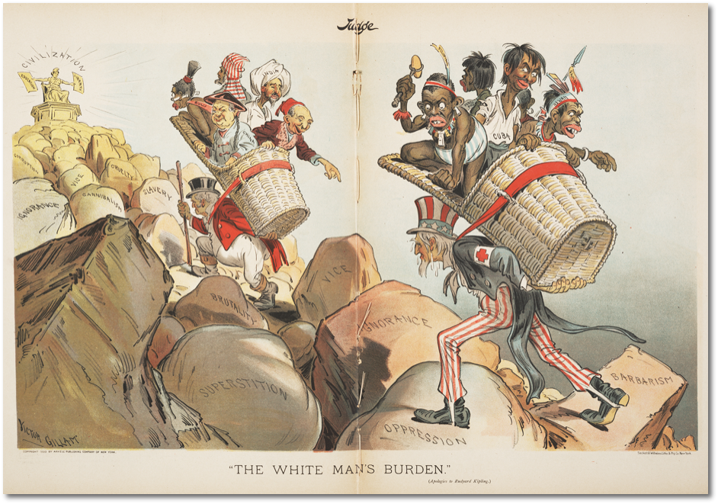
Source: | Audience: | Genre:
Summarize the central idea and supporting details | Exhibit critical insights (comment on such things as POV, credibility, evidentiary support etc.)
What critical questions came to mind as you read this document?

Apply the document to a larger issue or another text you have read.

What was the purpose of this document?

Convention Revising the General Act of Berlin, February 26,1885, and the General Act and Declaration of Brussels, July 2,1890
Whereas the General Act of the African Conference, signed at Berlin on February 26,1885, was primarily intended to demonstrate the agreement of the Powers (European Nations) with regard to the general principles which should guide their commercial and civilizing action in the little-known or inadequately organized regions of a continent where slavery and the slave trade still flourished;
Have agreed as follows:
ARTICLE 4. Each (European) State reserves the right to dispose freely of its property and to grant concessions for the development of the natural resources of the territory (African land), but no regulations on these matters shall admit of any differential treatment between the nationals of the Signatory Powers and of Stages, Members of the League of Nations, which may adhere to the present Convention.
ARTICLE 8. Each of the Signatory Powers shall remain free to establish the rules which it may consider expedient for the purpose of ensuring the safety and control of navigation, on the understanding that these rules shall facilitate, as far as possible, the circulation of merchant vessels.
ARTICLE 10. The Signatory Powers recognize the obligation to maintain in the regions subject to their jurisdiction an authority and police forces sufficient to ensure protection of persons and of property and, if necessary, freedom of trade and of transit.
ARTICLE 11. The Signatory Powers exercising sovereign rights or authority in African territories will continue to watch over the preservation of the native populations and to supervise the improvement of the conditions of their moral and material well-being. They will, in particular, endeavor to secure the complete suppression of slavery in all its forms and of the slave trade by land and sea.
ARTICLE 35. The Signatory Powers of the present Act recognize the obligation to insure the establishment of authority in the regions occupied by them on the coasts of the African continent sufficient to protect existing rights, and, as the case may be, freedom of trade and of transit under the conditions agreed upon.

Source: | Audience: | Genre:
Summarize the central idea and supporting details | Exhibit critical insights (comment on such things as POV, credibility, evidentiary support etc.)
What critical questions came to mind as you read this document?

Apply the document to a larger issue or another text you have read.

What was the purpose of this document?

Kaffir Boy Excerpts from Chapter 53 by Mark Mathabane: Mathabane was born in Alexandra, South Africa, an area that is a part of Johannesburg, the capital of the province of Gauteng. He was born to a life of poverty in the apartheid political setting of South Africa. His father was Jackson Mathabane, a labourer who had an income of $10 a month. Mathabane has also stated that his father struggled with alcohol and gambling, and was even abusive. Magdalene Mathabane was Mathabane's mother. She had been sold to Jackson Mathabane as a wife at the age of fifteen by her mother. Jackson and Magdalene Mathabane had seven children, of whom Mark Mathabane was the eldest.

The offices opened at ten, but I arrived at six in the morning. Already, hundreds of black men and women thronged outside its gates. Many were there for passes and permits to enable them to live and work in urban areas, to marry or move to another ghetto. Some in the multitude had been waiting in the queue for days, hoping that white madams and baases who daily came to the offices seeking cheap black labor would throw them a job as a garden boy or maid: they dared not leave the offices without a job, for if arrested they would be instantly deported to the tribal reserves.

There was fear, desperation and hopelessness in the eyes of many. People, angry and hostile, jostled each other to be first in line before the offices opened. Arrogant black policemen kept the multitude away from the gates with vulgar language and sjambok stabs. The offices opened. The queue moved at a snail’s pace; I struck up a conversation with an unemployed man in a dark suit. His name was Bra Modise, and he was from Soweto. He had been coming to the offices for over a month without success. A high school dropout, he used to work for a landscaping company; it went out of business, and he had to come to the offices to request a permit to hunt for another job.

I finished with the tables and was told to go down to several rooms at the end of the building for a physical. A black man walking alongside me said, “This place is hell, brother, just pray you only come here once. Never, never lose your stinker [pass]. People have been known to go mad, to commit suicide, rather than come here again.”
For the physical I was herded into a large room along with thirty or so black men, mostly migrant workers. We were ordered to strip down to the waist and line up facing the wall, waiting our turn at the x-ray machine. Our clothes lay in random bundles about the floor. There was talk from the white and black clerks carrying out the physical that some of the migrant workers had lice and needed to be fumigated. My senses were numb with anger; I moved about as in a nightmare, obeying every order. A black man in a white coat came up to me, jerked my right arm, and smeared it above the elbow with an acid ointment.
The ordeal lasted the entire day, at the end of which I seethed with hatred and anger; I wanted to kill somebody. I can’t take this degradation anymore, I told myself as I headed for the black bus stop, new passbook in hand: it contained my picture, fingerprints, address, employer’s address, age, colour of hair and eyes, height, tribal affiliation—it contained every detail of my life necessary for the police to know my life history upon demand, and I was supposed to carry the damn thing with me every hour of the day and night. But how could we blacks allow whites to do this to us—to degrade us, to trample our dignity—without fighting back? The fact that for the rest of my life I was doomed to carry the odious thing—a reminder of my inferior station in South African life—filled me with outrage and revived my determination to get to America. Not even a job at Barclays Bank was worth my freedom. If the scholarship offer came I would leave.

Source: | Audience: | Genre:
Summarize the central idea and supporting details | Exhibit critical insights (comment on such things as POV, credibility, evidentiary support etc.)
What critical questions came to mind as you read this document?

Apply the document to a larger issue or another text you have read.

What was the purpose of this document?

And you people who live...near Rugunga,... go out. You will see the cockroaches' (inkotanyi) straw huts in the marsh... I think that those who have guns should immediately go to these cockroaches... encircle them and kill them..."
Kantano Habimana on RTLMC, April 12, 1994[

It is 7.35a.m. here in Kigali. They will be struck by misfortune, they will be struck by misfortune (...). (...) those living in Mburabuturo, in the woods of Mburabuturo, look carefully see whether there are no Inyenzis inside.
Noël Hitimana, on RTLMC April 6-8 1994
In March 1993, Kangura (RPF newspaper) published an article entitled “A cockroach cannot give birth to a butterfly.” After 1990, opponents of the RPF called its troops Inyenzi, cockroaches, while the RPF itself used the term Inkotanyi, a name taken from a nineteenth-century military formation. The article said:
We began by saying that a cockroach cannot give birth to a butterfly. It is true. A cockroach gives birth to another cockroach...The history of Rwanda shows us clearly that a Tutsi stays always exactly the same, that he has never changed. The malice, the evil are just as we knew them in the history of our country. We are not wrong in saying that a cockroach gives birth to another cockroach. Who could tell the difference between the Inyenzi who attacked in October 1990 and those of the 1960s. They are all linked...their evilness is the same. The unspeakable crimes of the Inyenzi of today...recall those of their elders: killing, pillaging, raping girls and women, etc

Source: | Audience: | Genre:
Summarize the central idea and supporting details | Exhibit critical insights (comment on such things as POV, credibility, evidentiary support etc.)
What critical questions came to mind as you read this document?

Apply the document to a larger issue or another text you have read.

What was the purpose of this document?

Power Standards Prompt:

In the 19th century European countries carved up the continent of Africa. In a well-developed composition, discuss the motives for European Imperialism on the continent of Africa.

This argumentative essay should have:
- an introductory section that defines the Industrial Revolution (subject) and establishes not only what a revolution is but how the industrial revolution was in fact revolutionary (direction).
- a thesis and 2 body paragraphs that discuss at least two innovations that altered society to such an extent that we can call it revolutionary (reasons).
- a conclusion that meaningfully discusses the importance of writing about this subject and direction (significance).

Put your writing plan here.

