Step 2:
Selection of Topic

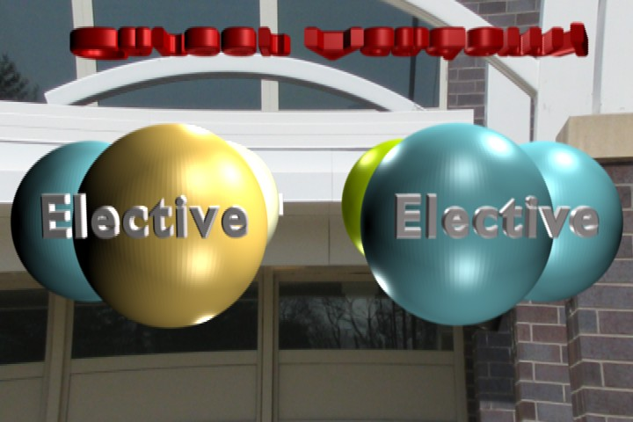 | What is your career pathway?  What electives do you plan to take in your career pathway? (Please list all of your related electives.)
Your capstone should take one of the topics that are common to your pathway electives and build a real world project out of that topic. Which topic will you select for your capstone?

How will your chosen electives help you create a project about this theme? (Be specific about each elective.)

Are you willing to work in a group? Circle Yes or No

Do you already have a group? Circle Yes or No. If so list the names of the people in your group along with their pathway

