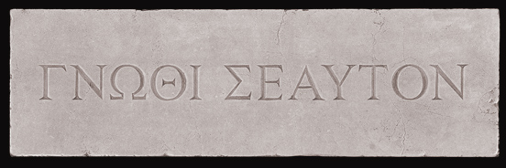
The Oracle of Delphi told Socrates there was no one wiser than him. He didn’t believe this because he was well aware of all that he didn’t know. Like the inscription above the Oracle’s door, gnothi seauton, Socrates knew himself. He knew what he didn’t know and couldn’t believe that he could possibly be the wisest person. So he set out to question everyone only to find sloppy thinking and intellectual bluster. His quest proved the Oracle correct. He was the wisest in all the land, because he knew what he didn’t know. Socratic Seminars take their name from Socrates, it is up to you to live up to this spirit.
Socratic Seminar
Topic:

Write your thesis statement about the topic here.

Provide and explain research based evidence that support your claims. Also be able to cite and defend your source including publication location and date of publication.

Discussion Questions: Remember, good questions are clear, open-ended, and provoke thought.
Remember to stay on TRACK
Test assumptions and explore inferences.
Refer to the text and other relevant sources.
Acknowledge changes in your perspective.
Clarify confusing statements and stay curious
Know what you don’t know and seek to fill in the gaps

What is your view of the topic after the discussion?

