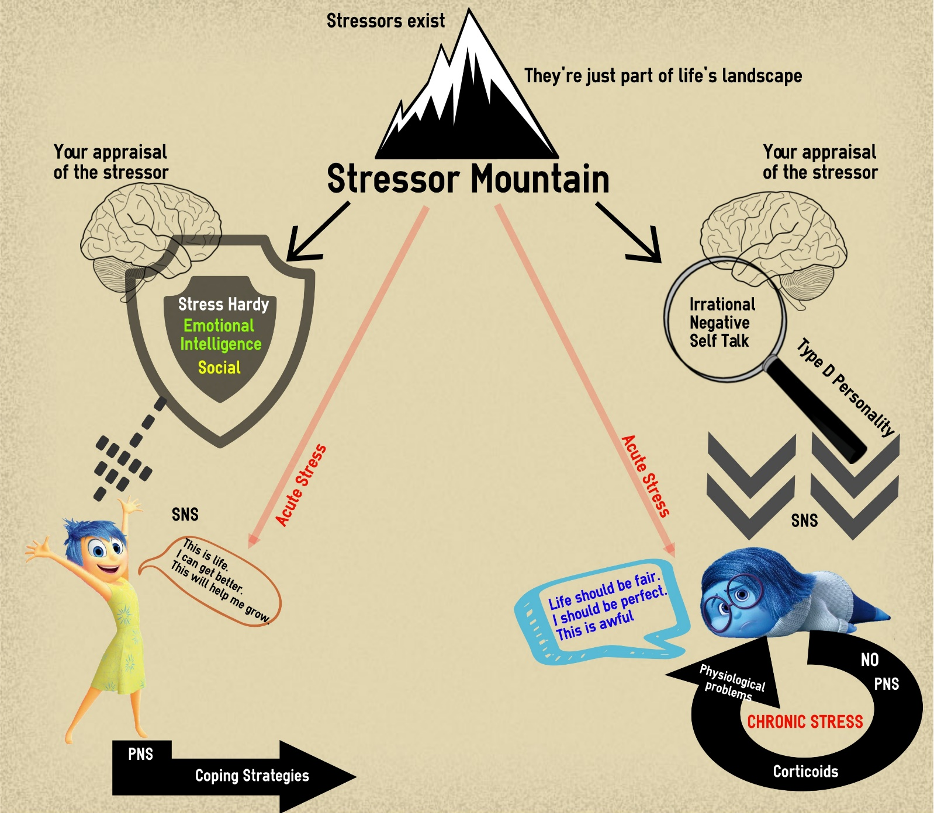
Essential Task 1-8: Identify the effects of stress on psychological/physical well-being and how to cope with stress

Key
= VT = Ex
= VP

