Essential Task 1-7: Discuss sources of stress (conflicts, frustration, etc.), measures of stress, and theories of stress (general adaptation theory)
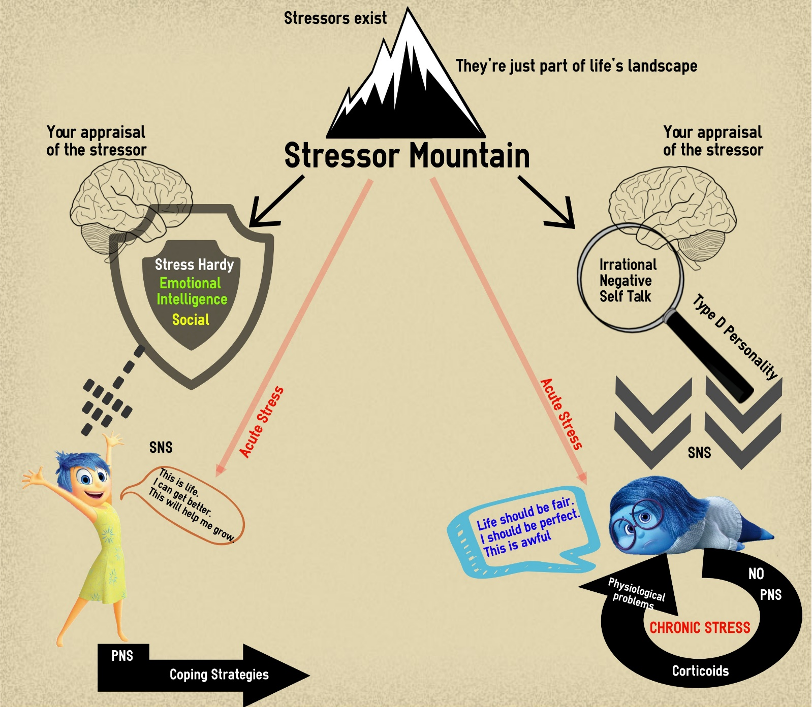

Evolutionary
GAS
Key
= VT = Ex
= VP

