End of the Year Project

**Video Satire Project**

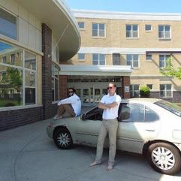



1. Select a familiar theme for example Cops, Cribs, A WHS Life, Typical Weymouth Girl, The Office, etc. (different theme for each group). Don’t worry about a plot as much as a way to tie your clips together.
2. Use that theme and your psychological knowledge to **satirize the absurdity of high school life and the college application process through a series of short vignettes/vines.**
3. You must include (on screen and in a meaningful way) at least 25 psychological terms or concepts.
4. Post your video on YouTube (7-10 minutes per group)
5. Be creative and biting
6. All members of your group must be obvious participants and involved in all aspects of the project: writing, acting, filming and editing.
7. While we are all looking to be entertained, the intellectual, course-related content must be present.
8. While we are all looking to be entertained, the presentation must be PG-rated and in good taste.
9. Use your phone. Edit in your phone. Film in Landscape NOT portrait so you don’t look like a newb. Watch out for the audio and make sure your clip is in HD. One tech savvy student will need to line all the clips up using a computer.
10. Presentation must be accompanied by a 2 page handout (for me) which   
    includes:   
    a. a rough outline of each scene

b. the term used in that scene

c. the definition of that term

Worth 160 points on Term 4.

You will be assessed using the school’s technology and collaboration rubrics.