7.4 – Effects of Stress and Coping With Stress
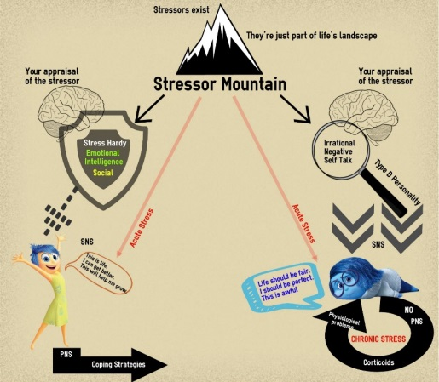
Harmful Appraisal
Stress Hardy

Indirect Coping
Direct Coping
Coping strategies
Health Problems

