7.4 Stress and Coping: H. Discuss theories of stress and the effects of stress on psychological and physical well-being.)
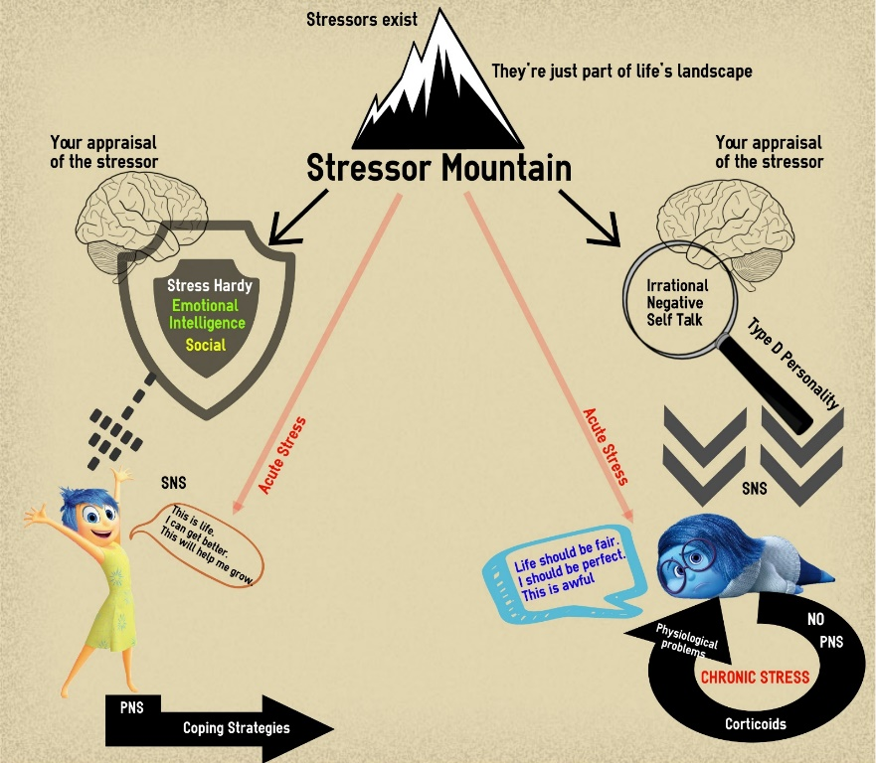
What is the real definition of stress?

Measures of Stress
SRRS

CUSS

Step 1 Stressors
Step 2 Appraisal
Step 3 Stress
Key
= VT = Ex
= VP
Evolutionary

Ex

GAS

Ex

Theories of stress
Chronic Stress

Ex

Acute Stress

Ex

