

3.4 Visual Perception  
H. Explain the role of top-down processing in producing vulnerability to illusion.

1. Convergence

Gestalt

**Visual Perception**

**Image Processing**

2. Retinal Disparity

Binocular Cues

**Depth Perception**

Figure Ground

Closure

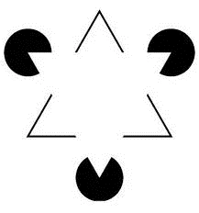

Continuity

Proximity

Similarity

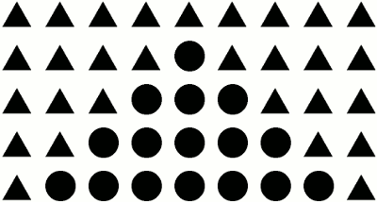

Monocular Cues

Relative Size –

Interposition

Relative Clarity

Relative Motion

Linear Perspective

AND