

3.1 Principles of Sensation  
A. Describe general principles of organizing and integrating sensation to promote stable awareness of the external world.  
B. Discuss basic principles of sensory transduction, including absolute threshold, difference threshold, signal detection, and sensory adaptation.  
C. Identify the research contributions of major historical figures in sensation and perception

Sensation

External Stimuli

Absolute Threshold

Difference Threshold

Perception

Receive the Signal

Transduction

Bottom Up

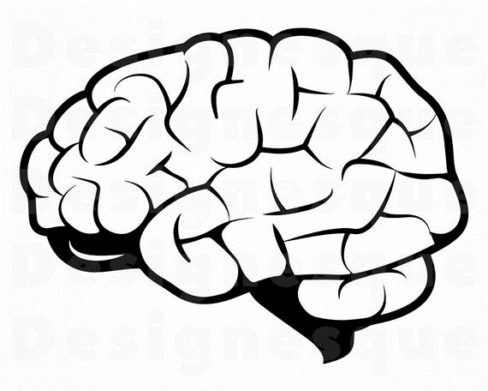

Bottom Up

Signal Detection

Sensory Adaptation